Alan D Horn 515733 Photography 3 Page 1 of 7
Contextual Studies Assignment 1
Photography and Reality
John Grierson (1898-1972), often cited as the founding father of British (and Canadian) Documentary, described the subject as "the creative use of actuality". Yet we are aware that the age-old perception that "the camera never lies" is simply untrue.
The manipulation of photographic images is as old as photography itself but the key issue is whether the manipulation is to deceive or mislead rather than modify for aesthetic or personal reasons.
With digital images today, post production manipulation is a capability of almost anyone who has a rudimentary appreciation of image-editing software ("Photoshopping") and the principle is used from simple cropping that cuts out unwanted features in the image to the extreme manipulation of an image that may include removing specific objects from the image or adding objects that were not there originally. None of this would seem serious as manipulation can be seen as creative and an art form – "artistic expression" - and as long as the author is clear about what has been done to the original image.
Example 1
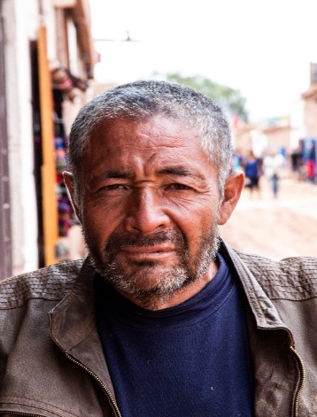 A portrait image of man I encountered in Atacama, Chile, (Feb 2019). Great features but the background is distracting.
Example 2
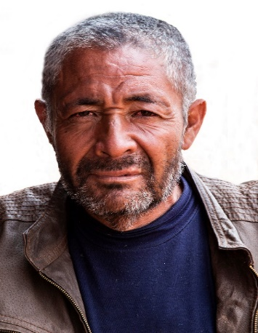
Background removed and subject stands out

Page 2 of 7

Example 3
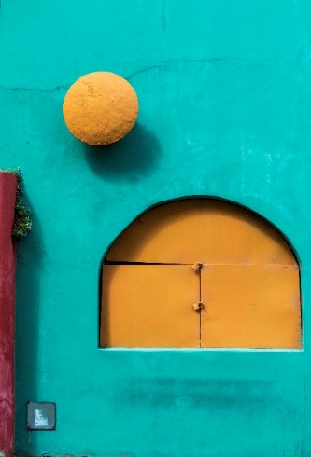 A building in Boca, Buenos Aires (Jan 2019). Distraction from air vent, shadow and part of another building.
Example 4
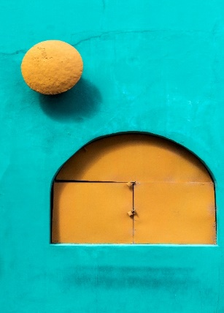 Distractions removed
In my opinion, the alterations have improved the images and I have not set out to mislead but to emphasise my subjects. Both altered images have seen success in international competitions, with Example 4 getting ten acceptances so far this year.
Nevertheless, if I was producing altered images for documentary and/or commercial purposes it would open a hornets' nest.
In Context and Narrative, Maria Short examines the subject of distortion from the photographer's perspective when planning the image (Levels of Truth p.11) and she lists a number of examples where a photographer's agenda is intended to "portray the moment, person, place, event in a particular way" which can include "expressions and physical gestures". I suggest that this is a concern about "staging".
In his The Photographer's Vision, Michael Freeman adds to this view. He is clear that (Deception p.118) "messing around with the situation and/or altering it digitally runs the risk of deceiving the audience and raises the question of dishonesty". Here, he concerns about both "staging" and post production alteration.
So where is the line drawn?
Page 3 of 7
There is reasonable doubt that a number of world-famous images were staged and the following two images are clear examples.

The first images of war dead in the American Civil War (Example 5), produced by Matthew Brady (1822-1896) in 1861 were heavily posed with Brady and his assistants positioning the dead soldiers for maximum impact. Regardless, the photographer and the images were endorsed (even encouraged) by the authorities due to the impact that they made on the public.

Example 5 Civil War Battle Scene 1861
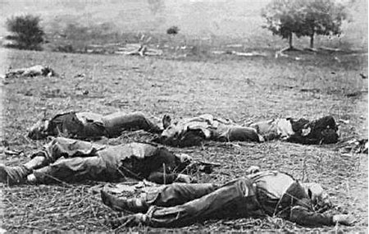

Whilst it might seem almost sacrilege, to doubt that the "Decisive Moment" (Example 6) image of Henri Cartier-Bresson (1908-2004) was not staged. The perfect reflection, the mirror image of the jumping man with the dancer's image on the billboard and the triangular relationship between the curved metal pieces and the puddle make it difficult to believe that this was Cartier-Bresson seeing a potential image, setting up and waiting for this to happen - as he claimed.

Page 4 of 7

Example 6 Place De l'Europe, 1932
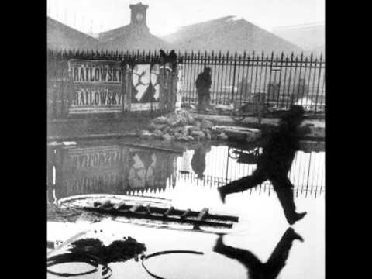
Cartier-Bresson explained his meaning of the decisive moment as – "one picture whose composition possesses such vigour and richness, and whose content so radiates outward from it, that this single picture is a whole story in itself". (Photography, Bate, D p.69)
There is no doubt that the image fits the parameters and the lasting impression is that an image taken almost 90 years ago, still has the ability to create admiration in its perfection. Did he really wait for the "decisive moment" or was it staged? Is it that important?
We see one example of misleading that was endorsed by the US Government and another that is surely poetic license at a time that reportage was in its infancy.

Today, the situation is completely different.
In the case of Marc Feldman, his treatment by Getty Images seems almost puritanical.
In July 2010 sports photographer, Marc Feldman submitted two images of golfer, Matt Bettencourt participating in a competition. One image was in portrait format with two people in the background and the second image was in landscape format with the two people almost removed through cropping. The editor of The Dallas Morning News, who originally thought that the images were from two sources informed Getty Images who "killed" the image and terminated its relationship with Feldman.
Page 5 of 7

Example 7

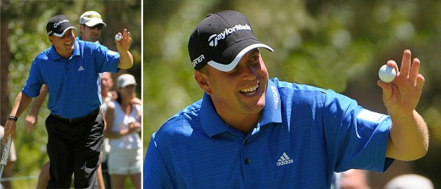
Feldman was aghast as he argued that there had been no real attempt to mislead, just to produce a better image. Whilst it seems harsh, especially as editors regularly crop images to manage page space, the social media reaction was mixed 50:50. Clearly there were those who felt sympathy but there was a hard core of photographers who endorsed the actions taken against him.
Perhaps there is more to the story than Lumm's article but it looks to me as an honest mistake that has had dire repercussions.
The case of Giovanni Troilio from Italy is much more dramatic. He won the highly prestigious Sony World Photography award in 2015 but his winning images turned out to be staged. His images were graphic scenes of a naked ritual and two people having sex in a car. The inference was that these scenes were typical within the Belgian City of Charleroi which he dubbed "The Dark Heart of Europe". The reputation of Charleroi is bad enough, with the former mining town generally viewed as derelict, poor and polluted with one of the highest crime rates in the country and one in four inhabitants unemployed (theculturetrip.com). However, the mayor, Paul Magnette took exception to Troilio's slight on the town suggesting that Troilio was settling scores and his work was a distortion of reality – and the images were not even taken in Charleroi.

Page 6 of 7

Example 8
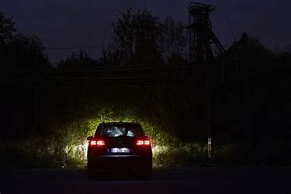
Initially there was reluctance to deal with the staging as the images were not altered. WPP managing Director commented – "Until this point (i.e. the intervention of the Charleroi mayor) we had upheld this award because there was no clear evidence to prove a rule had been broken" He went on to say "we now have a clear case of misleading information and this changes this changes the way the story is perceived………………a line has been crossed" (BJP 10 march 2015)
His first prize was annulled – yet his exhibition gained so much notoriety that he was offered several exhibitions!
This issue seemed to be the tip of the iceberg with 12% of the images being excluded over 2014/2015 (New York Times, Nov 25, 2015) and the World Press Photo concluded that a clear set of ethics would be introduced for 2016.
Their new rules are that entrants:
1 Must be aware of the influence their presence can exert on a scene they photograph and should resist being misled by staged photo opportunities.
2 Must not intentionally contribute to, or alter, the scene they picture by re-enacting or staging events.
3 Must maintain the integrity of the picture by ensuring there are no material changes to content.
4 Must ensure captions are accurate.
5 Must ensure the editing of a picture story provides an accurate and fair representation of its content.
6 must be open and transparent about the entire process through which their pictures are made, and be accountable to the World Photo Foundation for their practice

Page 7 of 7

Personal thoughts
My chosen Body of Work is Coastal Erosion, concentrating on the Norfolk coast line. I am fully aware that this subject can produce dramatic images but my intention is to ensure that the images and text will fit the WPP criteria.

References
Short, M (2011) Creative Photography, Context and Narrative, Lausanne, AVA Publishing
Freeman, M (2011) The Photographer's Vision, Lewes, ILEX
Lumm, J (2010) PetaPixel article
Bronx Documentary Center Altered Images
Bate, D (2016) Photography (2nd ed.) Bloomsbury (Documentary and Storytelling p.69)
British Journal of Photography 10 March 2015
Shutterbug 4 March 2015
Estrin,J (Nov 25 2015) World Press Photo Introduces New Ethics Guidelines for Contest New York Times

1395 words

